IdeationPhase

DefinetheProblemStatements

|  |  |
| --- | --- |
| Date | 19September2022 |
| Team ID | PNT2022TMID45666 |
| ProjectName | Virtual Eye - Life Guard For Swimming Pools To Detect Active Drowning |
| MaximumMarks | 2 Marks |

# CustomerProblemStatement:

# We create this problem statement to understand for customer’s point of view. This customer problem statement help to focus on what matters to create experience people will love.

# Safety in swimming pools is a crucial issue. This is a real time drowning detection method based on HSV color space analysis is presented which uses prior knowledge of the video sequences to set the best values for the color channels. Our method uses a HSV thresholding mechanism along with Contour detection to detect the region of interest in each frame of video sequences. The presented software can detect drowning person in indoor swimming pools and sends an alarm to the lifeguard rescues if the previously detected person is missing for a specific amount of time. The presented algorithm for this system is tested on several video sequences recorded in swimming pools in real conditions and the results are of high accuracy with a high capability of tracking individuals in real time. According to the evaluation results, the number of false alarms generated by the system is minimal and the maximum alarm delay reported by the system is 2.6 sec which can relatively be reliable compared to the acceptable time for rescue and resuscitation.

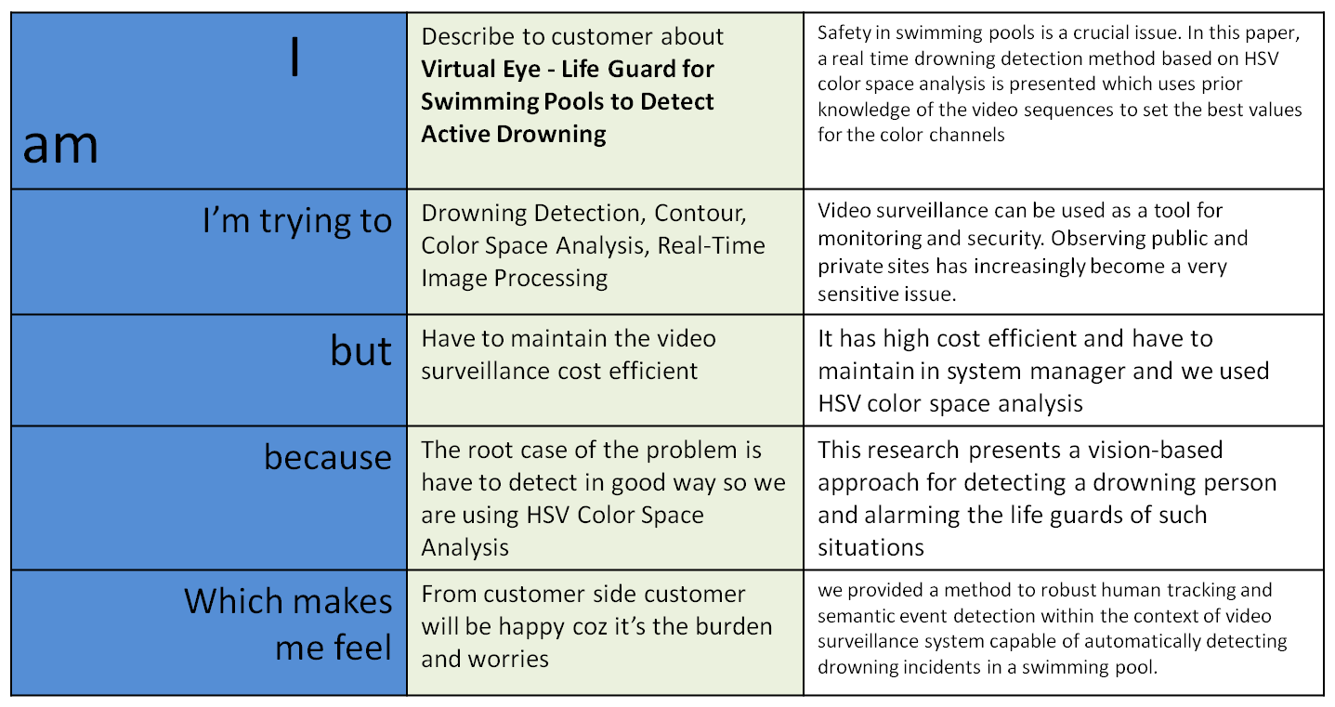

# Problem statement:

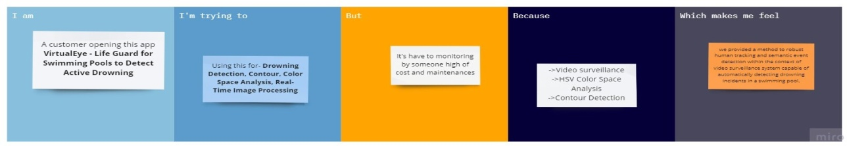

|  |  |  |  |  |  |
| --- | --- | --- | --- | --- | --- |
| **Problem**  **Statement(PS)** | **I am**  **(Customer)** | **I’mtryingto** | **But** | **Because** | **Whichmakesmefeel** |
| PS-1 |  |  |  |  |  |
| PS-2 |  |  |  |  |  |